**Project Design Phase-II**

**Data Flow Diagram & User Stories**

|  |  |
| --- | --- |
| Date | 31 January 2025 |
| Team ID | LTVIP2025TMID21141 |
| Project Name | Edu Tutor AI: Personalized Learning With Generative AI and LMS Integration |
| Maximum Marks | 4 Marks |

**Data Flow Diagrams:**

A Data Flow Diagram (DFD) is a traditional visual representation of the information flows within a system. A neat and clear DFD can depict the right amount of the system requirement graphically. It shows how data enters and leaves the system, what changes the information, and where data is stored.

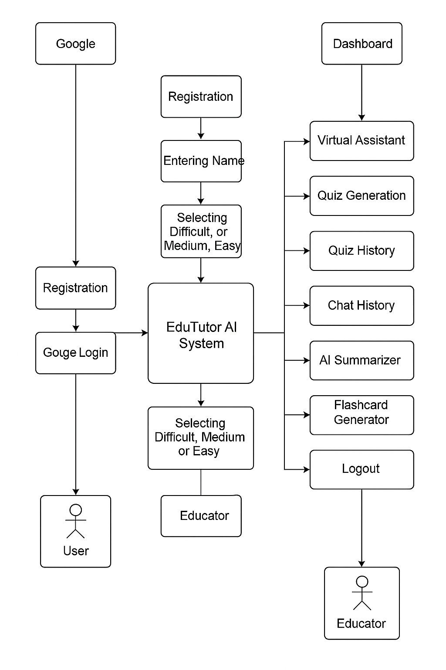

**User Stories**

Use the below template to list all the user stories for the product.

| **User Type** | **Functional Requirement (Epic)** | **User Story Number** | **User Story / Task** | **Acceptance criteria** | **Priority** | **Release** |
| --- | --- | --- | --- | --- | --- | --- |
| Customer (Mobile user) | Registration | USN-1 | As a user, I can register for the application by entering my email, password, and confirming my password. | I can access my account / dashboard | High | Sprint-1 |
| Customer (Mobile user) | Registration | USN-2 | As a user, I will receive confirmation email once I have registered for the application | I can receive confirmation email & click confirm | High | Sprint-1 |
| Customer (Mobile user) | Registration | USN-3 | As a user, I can register for the application through Facebook | I can register & access the dashboard with Facebook Login | Low | Sprint-2 |
| Customer (Mobile user) | Registration | USN-4 | As a user, I can register for the application through Gmail | I can register & access the dashboard with Gmail login | Medium | Sprint-1 |
| Customer (Mobile user) | Login | USN-5 | As a user, I can log into the application by entering email & password | I can access the dashboard | High | Sprint-1 |
| Customer (Mobile user) | Dashboard | USN-6 | As a user, I can view quizzes, attempt them, and track my progress. | I can see available quizzes and view performance graphs | High | Sprint-2 |
| Customer (Web user) | Dashboard | USN-7 | As a web user, I can view detailed quiz analytics and export results. | I can download performance reports and export results | Medium | Sprint-2 |
| Customer Care Executive | Query Handling | USN-8 | As a customer care executive, I can view and respond to user queries. | I can reply to user queries via email or dashboard | Medium | Sprint-3 |
| Administrator | User Management | USN-9 | As an admin, I can manage user roles, access levels, and remove inactive accounts. | I can assign roles, edit or delete user access | High | Sprint-4 |
| Administrator | System Monitoring | USN-10 | As an admin, I can monitor system performance and update the AI model. | I can access logs and manage model configuration | High | Sprint-4 |